**CHAPTER IV**

**PRESENTATION, ANALYSIS AND INTERPRETATION OF DATA**

       This chapter includes the system testing, analysis and interpretation of data, and presentation gathered by the researchers. These are presented in tables following the sequence of the research problem regarding the effectiveness of the system.

**System Testing**

This study involves a type of software testing in which the entire and integrated software undergoes testing with specific test cases. The aim of this testing is to assess the system's conformity with the stated requirements. To reach the desired outcomes, the researchers carried out the testing process, which included debugging of the program if errors were encountered. Several rounds of testing were performed to determine if the objectives of the study were met. To evaluate the system, the researchers conducted a post-evaluation survey and asked the respondents to use the system to determine its proper functioning. The testing was carried out by the researchers with the assistance of individuals experienced in face-to-face admission and entrance examinations, and the client. This testing was performed to determine the potential of the system for carrying out the client's process and to assess its usefulness for incoming students at Sta. Teresa College.

**Analysis and Interpretation of Data**

Data analysis and interpretation is the process of giving the information that has been obtained meaning and identifying the conclusions, relevance, and consequences of the results. It was a crucial and great stage in the study process. In every research study, data gathering is followed by analysis. Data analysis and interpretation were performed with the intention of turning the gathered information into reliable evidence of how the system turned out to be.

The researchers conducted a post-survey evaluation for fifty (50) respondents to determine if the objectives set for this online admission and online entrance examination have been reached. Also, the researchers tested the system online to know if it works properly.

**Standards of the System.** The student-respondents assessed the different standards of the system in terms of functionality, reliability, usability, efficiency, portability and maintainability.

**Functionality.** Table 5 presents the post-survey assessment of the respondents on the functionality of the system.

**Table 5. Functionality of the System**

|  |  |  |  |
| --- | --- | --- | --- |
|  | **Mean** | **Standard Deviation** | **Verbal Interpretation** |
| **Accurateness**  The software provides correct output | 3.42 | 0.57 | Moderately Effective |
| **Suitability**   1. The software provides an appropriate set of functions for   specified tasks and user objectives. | 3.36 | 0.60 | Moderately Effective |
| **Security**  The software protects data from unauthorized persons or systems. | 3.32 | 0.55 | Moderately Effective |
| **Interoperability**  The software interacts with other components or systems. | 3.24 | 0.66 | Moderately Effective |
| **Weighted Mean** | **3.34** | **0.60** | **Moderately Effective** |

It can be seen from the table that the overall assessed level functionality of the system is moderately effective based on the obtained a weighted mean of 3.34. The respondents assessed that the system is providing correct output as moderately effective. This item got the highest mean of 3.42 with standard deviation of 0.57 This indicates that the respondents regard first the accurateness due to the software correct output.

Moreover, the suitability and security of the system are assessed by the respondents as moderately effective. These items obtained corresponding means of 3.36 and 3.32; respectively. This could mean that the system is providing appropriate set of functions for specified tasks and user objectives. Moreover, it is protecting data from unauthorized persons or systems.

It can be noted that the interoperability of the system was rated by the respondents with the lowest mean of 3.24 with standard deviation of 0.66. This indicates that the software is interacting with other components or systems with moderate effectiveness.

**Reliability.** The students’ post-survey assessment on the reliability of the system is shown in Table 6.

**Table 6. Reliability of the Application**

|  |  |  |  |
| --- | --- | --- | --- |
|  | **Mean** | **Standard Deviation** | **Verbal Interpretation** |
| **Recoverability**  The software brings back to previous full operation after failure. | 3.26 | 0.63 | Moderately Effective |
| **Fault tolerance**  The software maintains the same level of performance. | 3.24 | 0.56 | Moderately Effective |
| **Maturity**  The software avoids failure as a result of a fault. | 3.20 | 0.61 | Moderately Effective |
| **Weighted Mean** | **3.23** | **0.60** | **Moderately Effective** |

It can be gleaned from the results that the respondents rated the recoverability of the system as moderately effective. Being able to bring back to previous full operation after failure got the highest mean of 3.26 with corresponding standard deviation of 0.63. This implies that system is easily brings back to full operation after failure.

This s followed by fault tolerance in which the system is maintaining the same level of performance. This item obtained a mean of 3.24 and interpreted as moderately effective. This could mean that the system has a balance level of performance during the operation.

It can be noticed that the maturity of the system as rated by the respondents with the lowest mean of 3.23. This indicates that the system is moderately effective in avoiding failure as a result of a fault. This indicates that the online admission and entrance examination based on the maturity is avoiding the failure on the system to create and have a fault. The overall interpretation of reliability of the proposed system obtained a weighted mean of 3.23 and the interpretation of moderately effective which means the software served as a helpful tool in the school and achieved requirements of the study.

**Usability.** Table 7 reflects the post-survey assessment of the students on the usability of the system**.**

|  |  |  |  |
| --- | --- | --- | --- |
|  | **Mean** | **Standard Deviation** | **Verbal Interpretation** |
| **Understandability**  The software enables the user to understand how it can be used for a particular task. | 3.38 | 0.67 | Moderately Effective |
| **Learnability**  The software is easy to learn with minimum supervision. | 3.38 | 0.60 | Moderately Effective |
| **Recoverability**  The software enables the user to operate and control it. | 3.28 | 0.73 | Moderately Effective |
| **Weighted Mean** | **3.35** | **0.67** | **Moderately Effective** |

**Table 7. Usability of the System**

Results revealed that the overall assessment of the respondents on the level usability of the system is moderately effective with a weighted mean of 3.35. The respondents assessed that the system enables the user to understand how it can be used for a particular task and it is easy to learn with minimum supervision as moderately effective. Both items equally rated by the respondents with a mean of 3.38. This implies that the respondents apparently considered the understandability and learnability of the system because the user can learn and use the system without much effort and with a minimum supervision. So that the researcher believe that the system reached the objective.

For the recoverability of the system, the respondents rated this with the lowest mean of 3.28 with standard deviation of 0.73. This could mean that they perceived that the system can be operated and controlled by the user only to moderate effectiveness.

**Efficiency.** The post-survey assessment of the students on the efficiency of the system is presented in Table 8

**Table 8. Efficiency of the System**

|  |  |  |  |
| --- | --- | --- | --- |
|  | **Mean** | **Standard Deviation** | **Verbal Interpretation** |
| **Resource Utilization**  The software uses appropriate amounts and types of resources when the software performs its function. | 3.40 | 0.64 | Moderately Effective |
| **Time behavior**  The software provides appropriate response and processing times and throughput rates when performing its function. | 3.26 | 0.69 | Moderately Effective |
| **Weighted Mean** | **3.33** | **0.67** | Moderately Effective |

It can be gleaned from the results that the respondents rated the efficiency of the system as moderately effective. Using the appropriate amounts and types of resources when the software performs its function got the higher mean of 3.40. This resource utilization was assessed as moderately effective by the respondents with corresponding standard deviation of 0.64. This implies that the system has an appropriate function and it perform well.

With regard to the time behavior of the system, it was rated by the respondents with a mean of 3.26. This indicates that the system is moderately effective in providing appropriate response and processing times and throughput rates when performing its function. This indicates that the system has a time behavior in performing. The overall interpretation for efficiency of the proposed system obtained moderately effective which means the software achieved the requirements of the study.

**Portability.** Table 9 shows the post-survey assessment of the students on the portability of the system.

**Table 9. Portability of the System**

|  |  |  |  |
| --- | --- | --- | --- |
|  | **Mean** | **Standard Deviation** | **Verbal Interpretation** |
| **Replaceability**  The software works in the same environment after upgrading. | 3.38 | 0.57 | Moderately Effective |
| **Adaptability**  The software adapts to different environments without applying actions or means other than those provided. | 3.28 | 0.64 | Moderately Effective |
| **Install ability**  The software installs in the specified environment. | 3.20 | 0.67 | Moderately Effective |
| **Weighted Mean** | **3.29** | **0.63** | **Moderately Effective** |

It can be gleaned from the results that the respondents rated the replaceability of the system as moderately effective. This got the highest mean of 3.38 with corresponding standard deviation of 0.57. This implies that the respondents regard that the system is working in the same environment after upgrading.

This is followed by the adaptability of the said system. This item obtained a mean of 3.28 and interpreted as moderately effective. This could mean that the system can adapt to different environments without applying actions or means other than those provided. This indicates that the system adaptability adapts different environment.

It can be noticed that the install ability of the system is rated by the respondents with the lowest mean of 3.20. This indicates that the system is moderately effective in installing in the specified environment. This indicates that the software installs in the specified environment. The overall interpretation of reliability of the proposed system obtained a weighted mean of 3.29 and the interpretation of moderately effective This implied that the software can be easily accessed in all devices.

**Maintainability.** Table 10 presents the post-survey assessment of the respondents on the maintainability of the system.

**Table 10. Maintainability of the System**

|  |  |  |  |  |
| --- | --- | --- | --- | --- |
|  | **Mean** | **Standard Deviation** | | **Verbal Interpretation** |
| **Changeability**  The software enables modifications to be implemented. | 3.36 | 0.60 | | Moderately Effective |
| **Analyzability**  The software identifies causes of failure or the parts to be modify. | 3.32 | | 0.59 | Moderately Effective |
| **Testability**  The software enables modified software to be validated. | 3.28 | | 0.61 | Moderately Effective |
| **Stability**  The software avoids unexpected effects from modifications. | 3.24 | | 0.77 | Moderately Effective |
| **Weighted Mean** | **3.30** | | **0.64** | **Moderately Effective** |

Results from the table shows that the respondents rated the maintainability of the system as moderately effective based on the weighted mean of 3.30. This could mean the researchers ensure that the system complied on maintaining its same level of performance.

The system is moderately effective in allowing modification to be implemented. This got the highest mean of 3.36 with corresponding standard deviation of 0.60.

This is followed by analyzability in which the system can identify the causes of failure or the parts to be modified. This item obtained a mean of 3.32 and interpreted as moderately effective.

It can be noticed that the testability of the system is rated by the respondents as moderately effective with a mean of 3.28. This indicates that the system can modify the software to be validated.

It can be noticed that the stability of the system got the lowest mean of 3.24. This indicates that the system is moderately effective in avoiding unexpected effects from modifications.

**Presentation of software design and user Interface**

         The design of the user interfaces incorporated in the system application is showcased in this section. The researchers utilized the Waterfall Software Development Model to create the intended design and functionality of the online Scholarship Application Program. Utilizing various data gathering methods and tools, the researchers gathered the requirements for the online admission and entrance examination process.

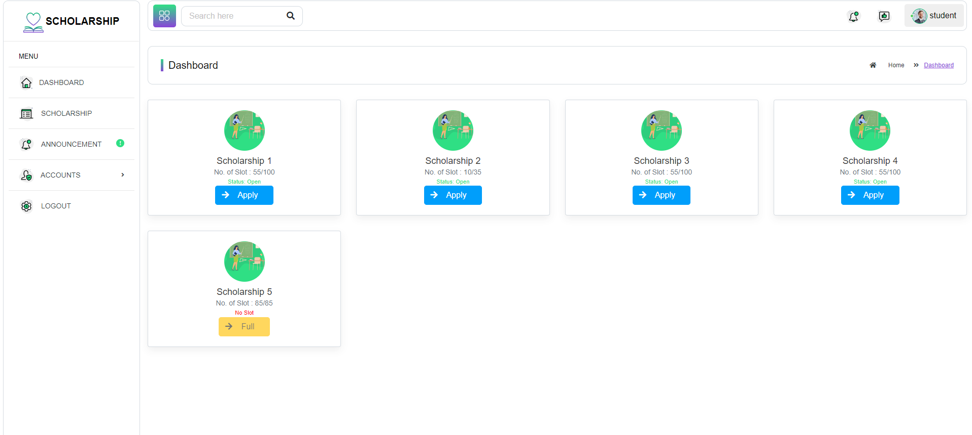**User Interface.** It includes the design of the system for the easiest process and fastest transaction for Scholarship Application Program.

**Figure 5. The Dashboard (Student POV)**

Figure 5 shows it shows the sidebars such as Dashboard, Scholarship, Announcement, Accounts, and Logout. The dashboard shows all the program, available scheme, and how many slots left in every scheme. The form shows all programs. The status shows the remarks of admin to your application forms.



**Figure 6. Log in Page**

Figure 6 describes the login form of the system, presenting an interface that consists of two textboxes: one for the username and another for the password. To access the encrypted password, User need to click on the eye button located on the right side of the password textbox. Within this form, users can log in using their existing account. In case a user doesn't have an account, they can navigate to the sign-up form by clicking on the designated word. Additionally, if users forget their password, they can click on the "Forgot Password" option, and the system will send them a password reset link via email.

.

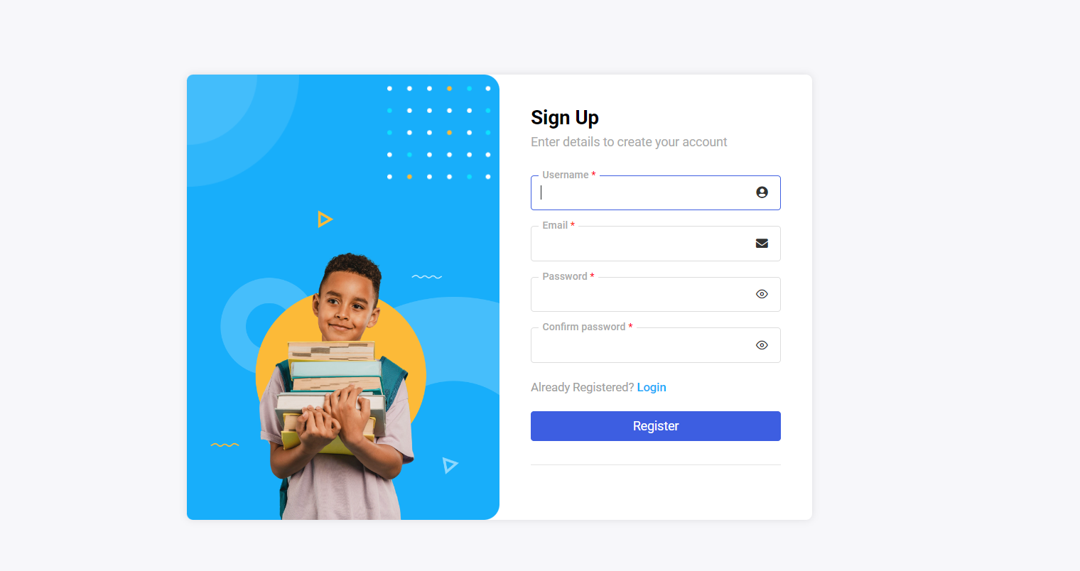

**Figure 7. Sign Up form**

Figure 7 shows the sign up form of the system, which displays the required personal information that users need to provide if they don't already have an account. Once users complete the form, they can click the submit button to register their account. Afterward, users will be directed to the Verify Email Page, and the system will send them an email for account verification purposes.  
  
  
  
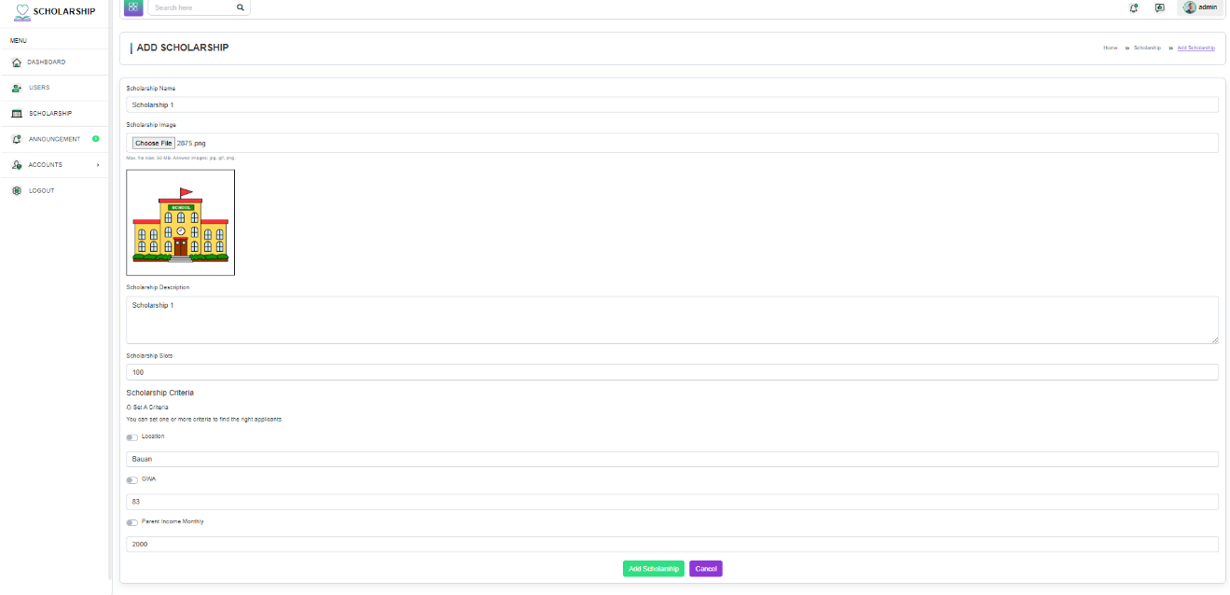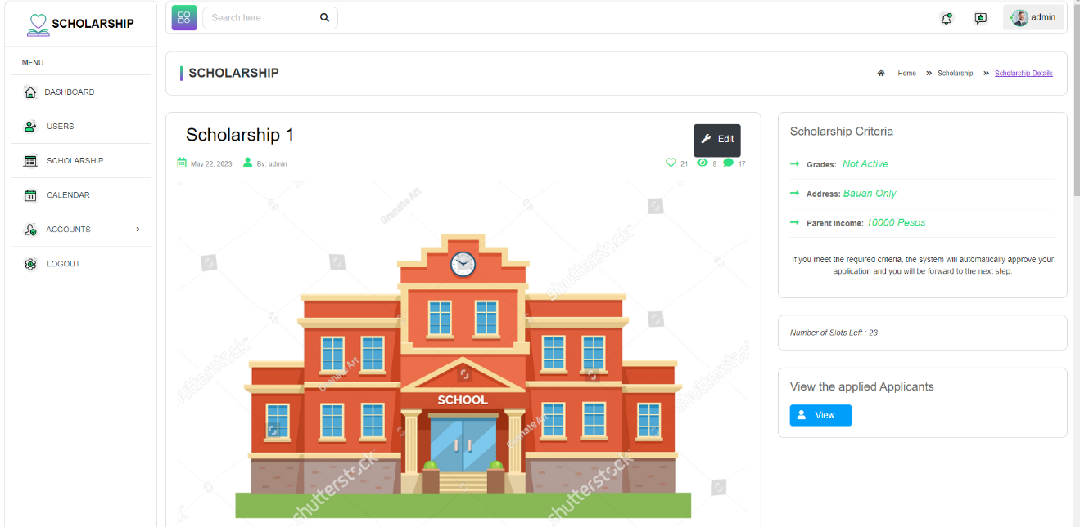

**Figure 8. Scholarship Application**

Figure 8 shows the Scholarship Application. The Scholarship Coordinator can filled out all the needed information, such as Scholarship name, Scholarship Image, Number of Slot and Scholarship Criteria All the needed information provided by the Scholarship Coordinator can be updated and edited.

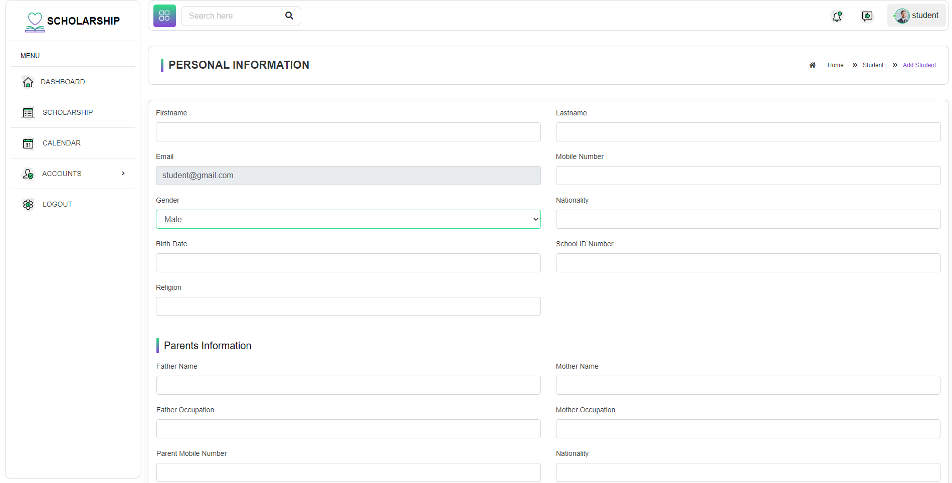

**Figure 9. Application Form**

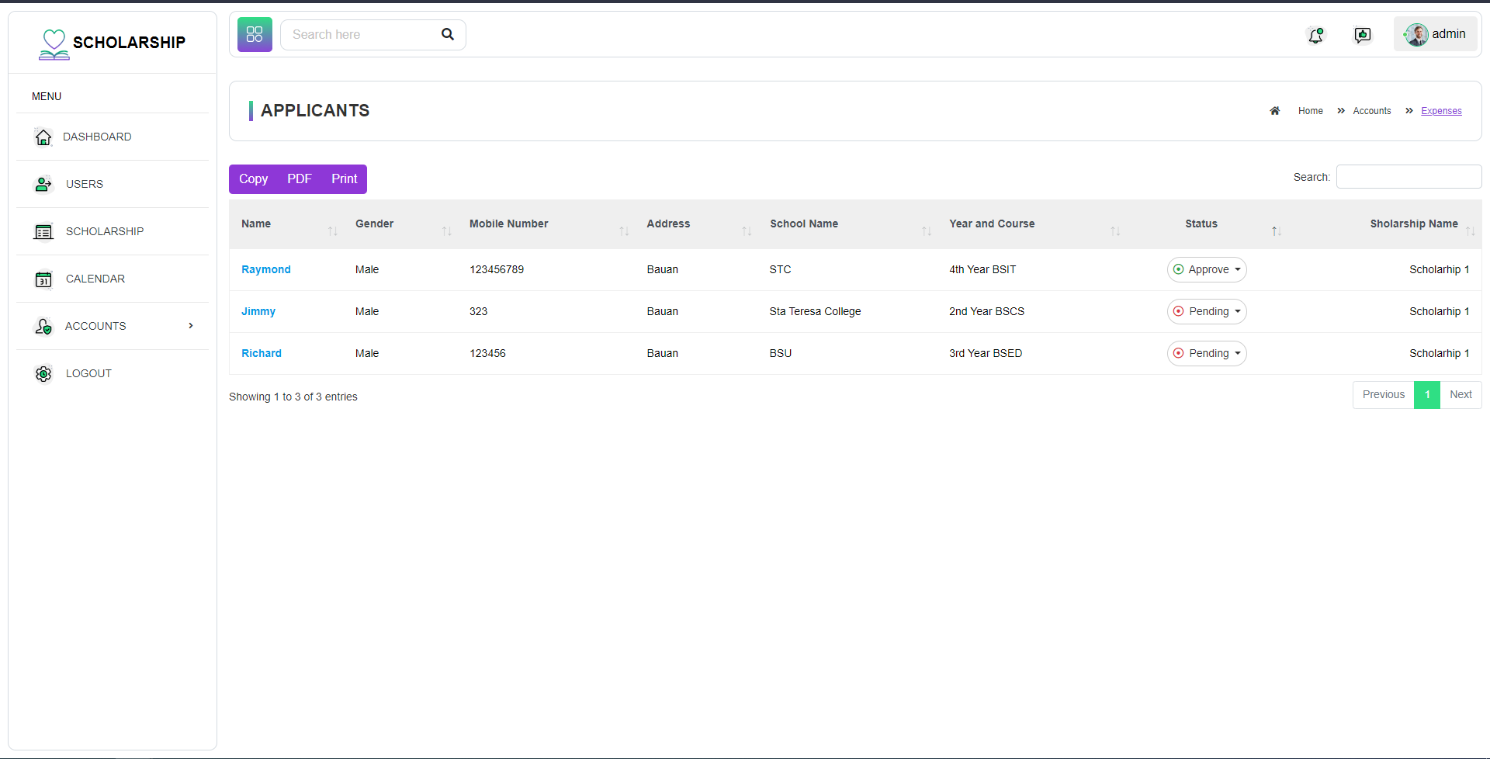Figure 9 shows is the application form that is need to be filled out by the students.

**Figure 10. Scholarship Applicants**

Figure 10 shows the Scholarship Applicants.

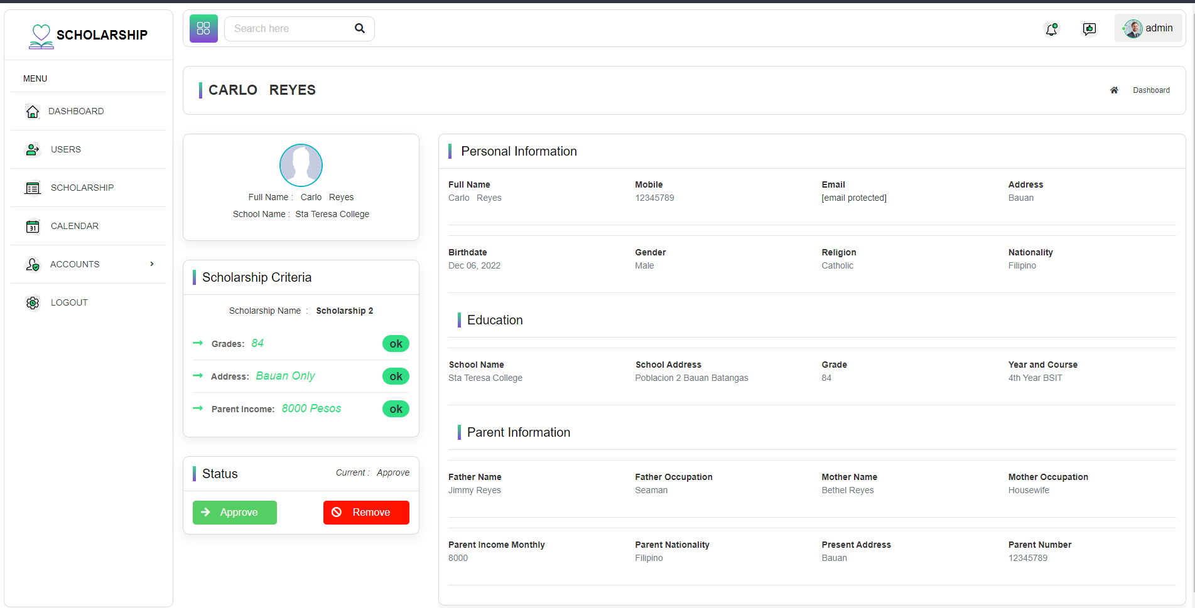  
  
  
**Figure 11. Scholarship Applicant Detail**

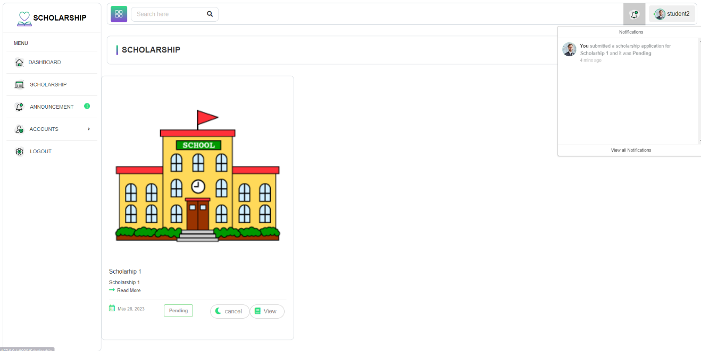Figure 11 shows the Scholarship Applicant Detail here the scholarship coordinator can see if the student have passed their requirements and also the scholarship coordinator can view all the information of the current student.

**Figure 12. Scholarship Application Notification**

Figure 12 shows the notification module of the system, the notification appears when the admin receive the application form of the students who applied in the said Scholarship Program. Also the system notified the student whether they meet the need requirements or not.

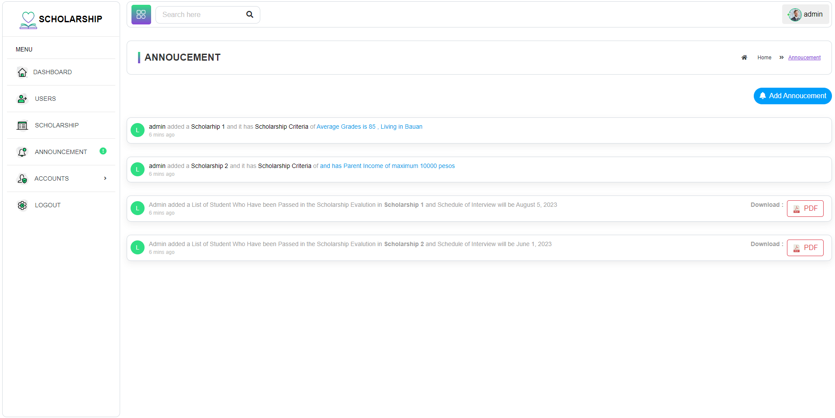

**Figure 12. Scholarship Announcement**

Figure 12 shows the announce coming from different scholarship coordinator. The scholarship coordinator can set a announcement and the date when the schedule of interview and the student can view this by clicking the announcement button in side bar menu.

**CHAPTER 5**

**SUMMARY OF FINDINGS, CONCLUSION AND RECOMMENDATION**

This chapter presents the summary, findings, conclusions, and recommendations of the study.

**Summary**

This capstone project entitled “Online Student Admission and Testing Management System for STC College Department” is a web-based system for Sta. Teresa College students. This system generates better services to school, guidance office, and to incoming students. In this Online Student Admission and Testing Management System, the submission of the requirements required in the student’s application will be organized easily and it also be edited if the student has missed one of the requirements needed. The main goal of this system is to provide easiest online admission and testing for the incoming students. And easily manage by the guidance personnel.

The web-based system has a website as the main page of the presented system that shows the Online Admission/application, Online Examination, and some reminders for students about the admission and testing rules. For the admission process, the student register first and fill out the information and capture a picture to have an account. The admission contains personal information about the students and school requirements that need to be submitted and the testing that contains questions with face recognition of the students. This system helps the guidance personnel to lessen the paperwork and to organize the school requirements of the students in the easiest way. The student can fill out their application through online admission even if they are at home. As a result, the total number of admissions of the students will be seen at the guidance personnel and the guidance personnel will approve the student to proceed to the examination. After the approval of the admission, guidance personnel will receive the application of the student and the guidance personnel will create an account for the student’s examination. The admin will receive the results of the examination and will provide a report on it.

Specifically, the researchers aim to achieve the following objectives:

1. To create an online student admission and testing management system that will cater to all the admission activities of new/incoming students.
2. To allow the admission office personnel to be able to evaluate the student record and manage the entrance examination of the student online.
3. To evaluate the proposed online student admission and testing management system based on ISO 9126 standard for software quality.
4. To prepare an implementation plan for the proposed Online Student Admission and Testing Management System for STC College Department.

The researchers provided questionnaires to 82 respondents for pre-survey and 50 respondents for post survey to meet the objectives. The respondents were the students of 1st year college of Sta. Teresa College.

**Findings**

The following results were achieved based on the objectives of the study

1. **Created an online student admission and testing management system.** A website that features online student admission and testing management will cater to all the admission activities of new/incoming students. Guidance personnel and administrators can monitor the system.
2. **Management and evaluation of student record by admission office personnel**. The system that can be manage and monitor by guidance personnel. Cellphones, tablet, laptop and personal computer can access the system through the use of web browsers and internet connection. All the records of new applicants can be evaluated and manage the entrance examination of student online.
3. **Prepare an implementation plan.** A system that complies on ISO 9126 standards for software quality helps the system to be implemented. ISO 9126 standards for software quality played a vital role for the development of the capstone project.

**Conclusion**

Based on the findings of this study, the following conclusions were obtained by the researchers:

1. Online Student Admission and Testing Management System provides features that cater to all the admission activities of new/incoming students.
2. The system improves all school admissions activities and makes it possible for admissions office to evaluate a student’s record and manage an online entrance exam for the student.
3. The Online Student Admission and Testing Management System was found to be moderately effective and complies with ISO 9126 standards based on the post-survey result.

**Recommendations**

Based on the findings and conclusions mentioned above, several recommendations were provided to enhance the developed system. These suggestions aim to address the identified issues and improve the system's performance.

1. During the online examination, use laptops or personal computer for more better experience.
2. When using the system, use the latest version of Google Chrome for best results. Other features can’t function well in the old version of Google Chrome.
3. System can add other features as long as it will help the success of the online admission and testing management system.
4. Use API with subscription to use of all the features provided in face recognition. Unlike to free subscription some features are not available and accessible
5. The researchers are recommending the guidance personnel and administration to use the system to replace the pen and paper process in admission and examination.
6. To all the future researchers who will take steps to improve the proponents’ system, the researchers are suggesting to continue the present study and add more features to make it more useful.